Casey Gray
ITEC 4365
February 25, 2025
Programming Assignment 2

- First Stage
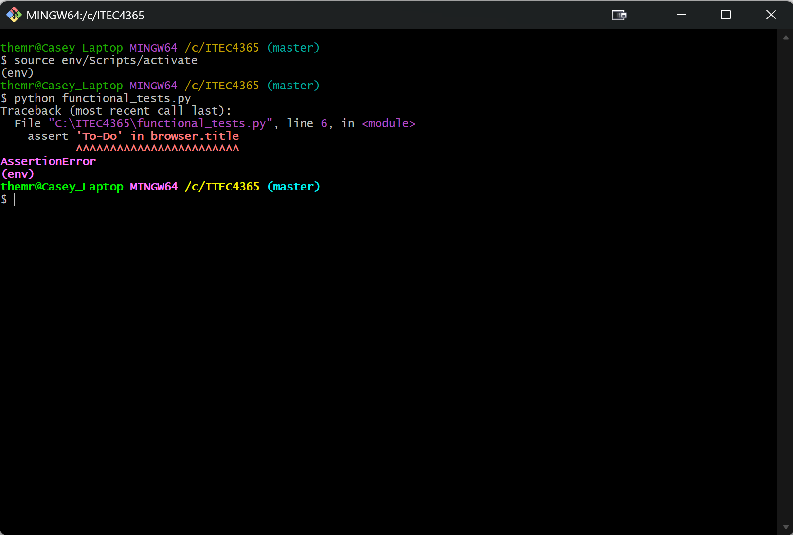
- Second Stage
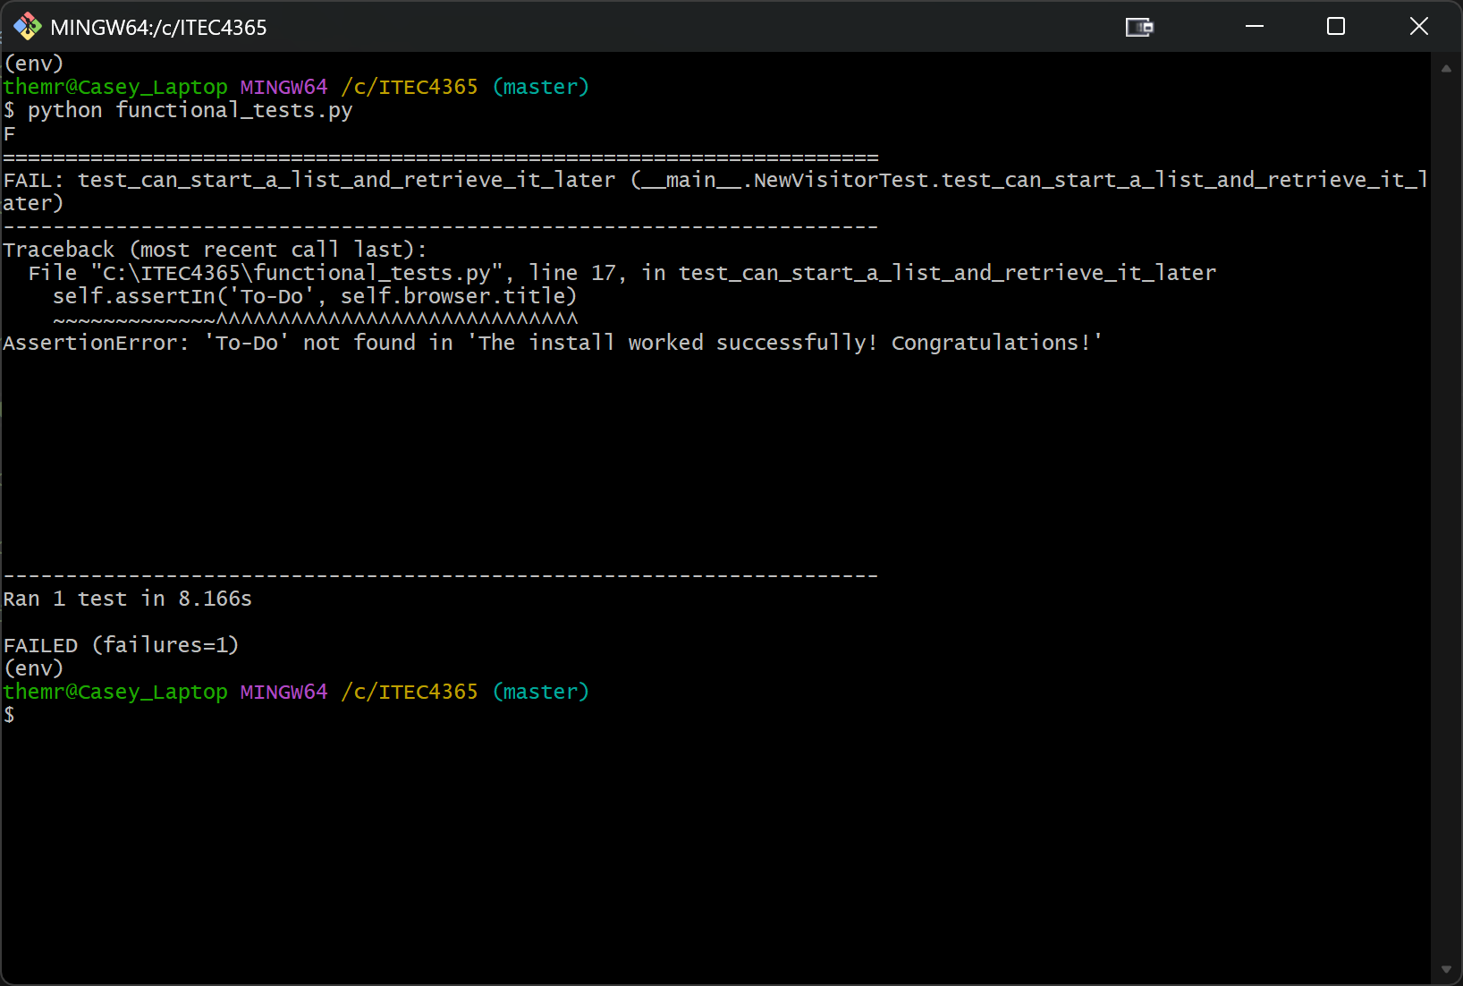
- Third Stage
  - git diff
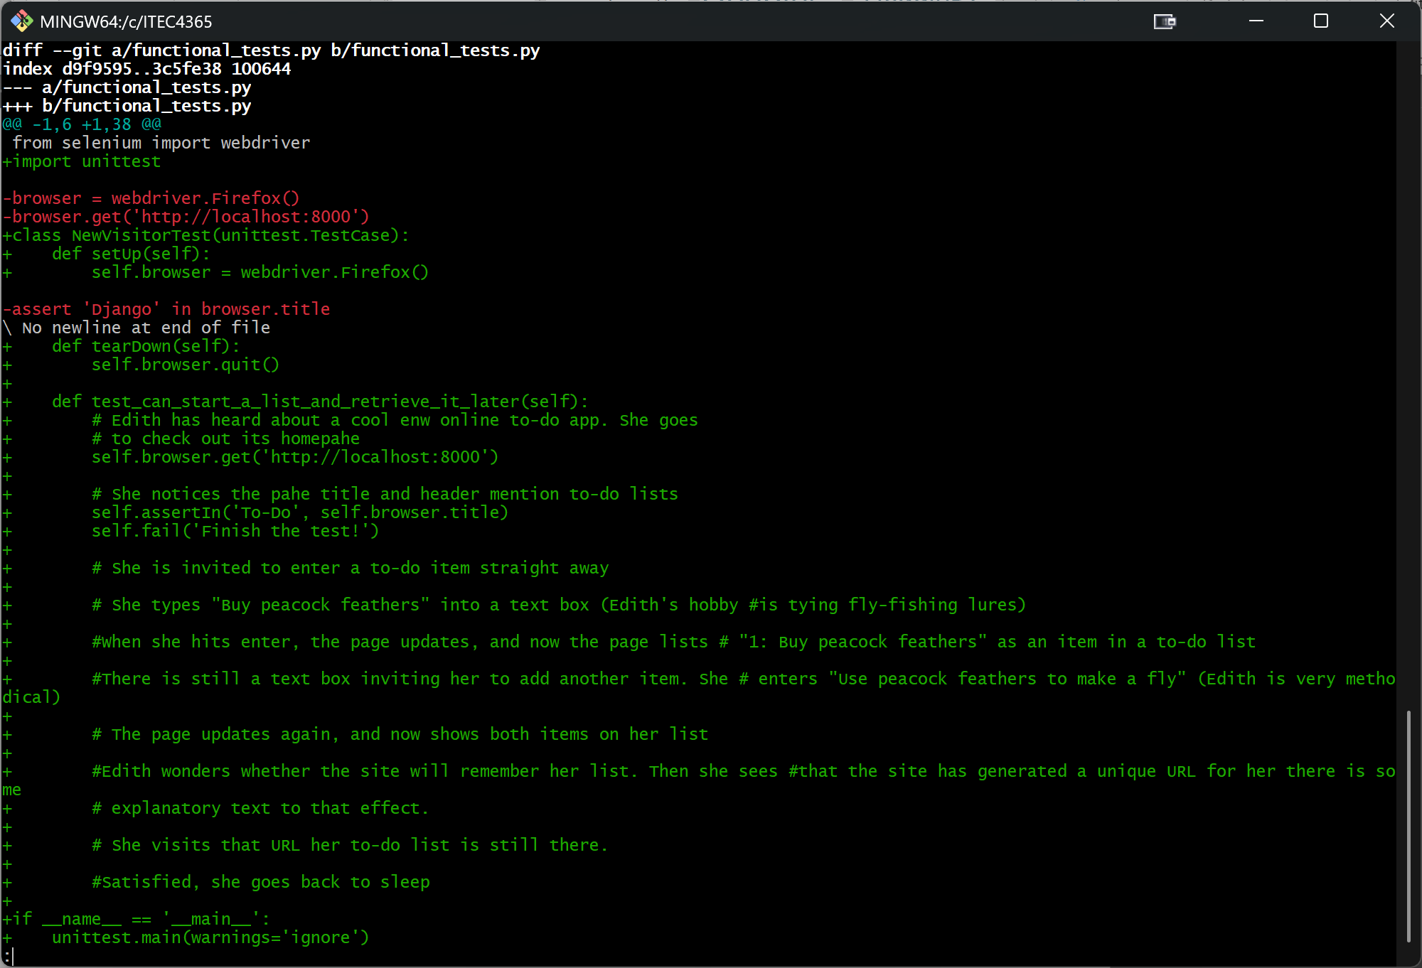
  - git commit -a
